Step 1: Open your web browser and navigate to the AWS Free Tier Page
Step 2: On the middle click Create a Free Account
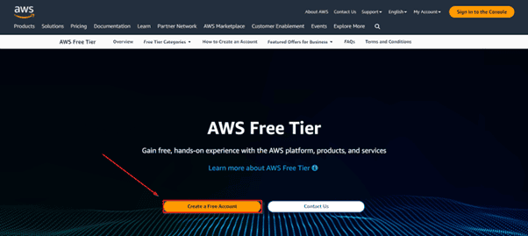
Step 3: Verify your email address.
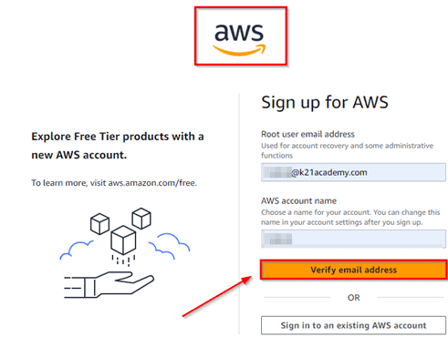
Provide details: Provide the details that you want to use (Root Email and AWS Account Name) and click Verify email address
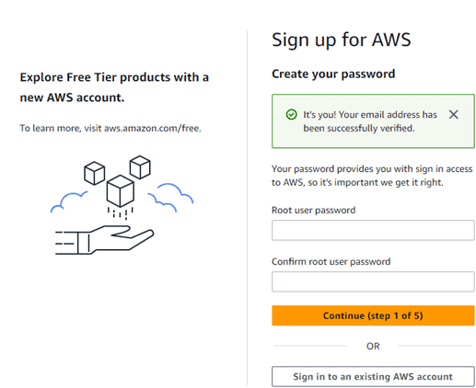
- Password: Type your Password
- Confirm password: Confirm the Password
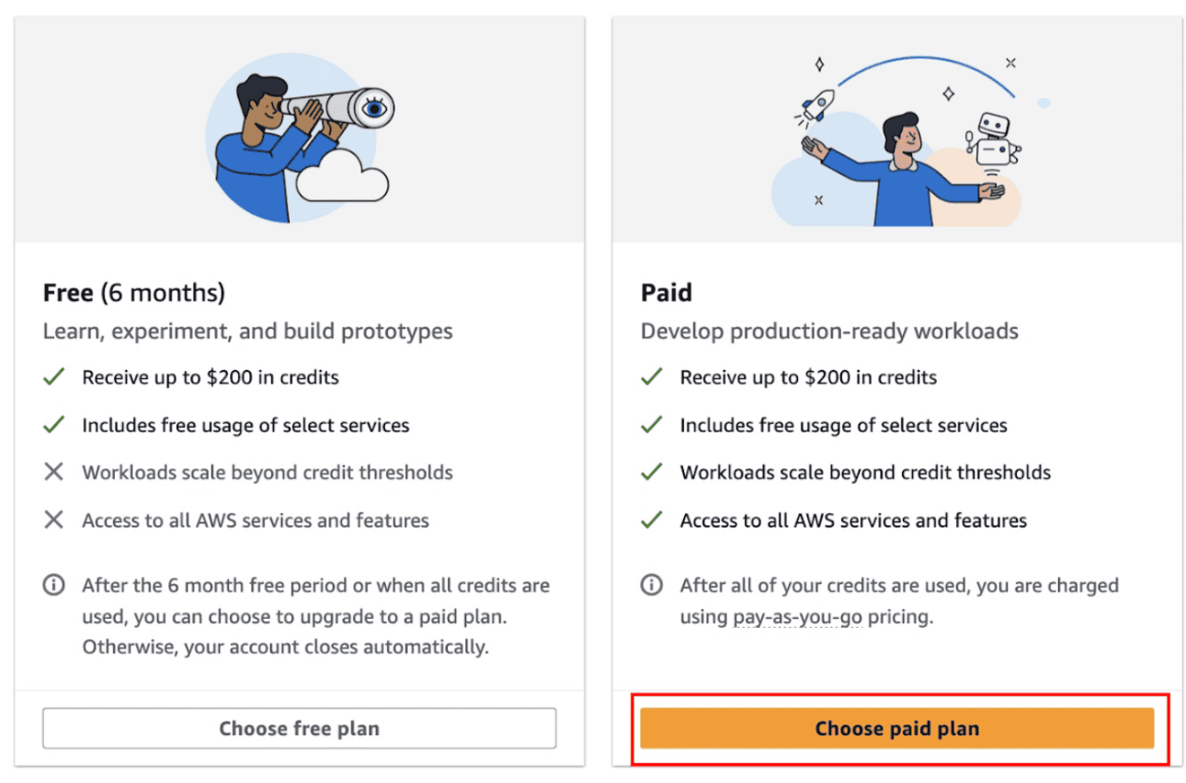
Click: Choose free plan

Step 4: Contact Information
Select your AWS type (Personal).
Full name, Phone number, Country or Region, Address, City, State, Postal Code
Fill in the correct information to validate your account if you’re going to create a personal use account, then click on Continue
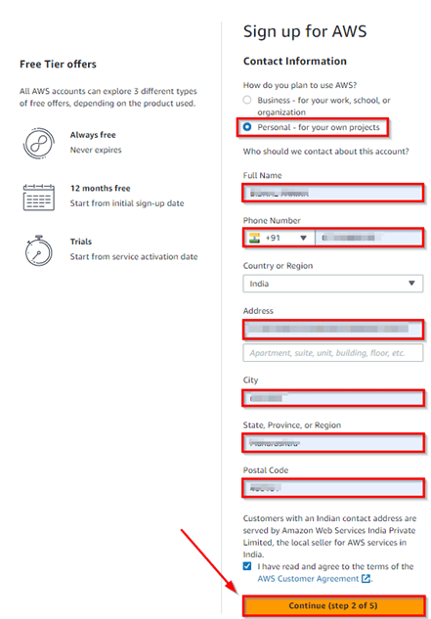
Make sure to provide proper contact details and mobile number to get the Verification code from AWS.
Step 5: Payment and PAN information: In this step, you must fill in your credit card /Debit Card info and billing address and click on Secure Submit.
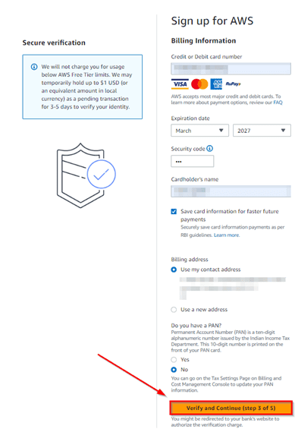

Step 6: In this step, it will take you to the payment gateway to validate your payment information, and for your credit card verification, Amazon will charge the minimum price based on your Country.
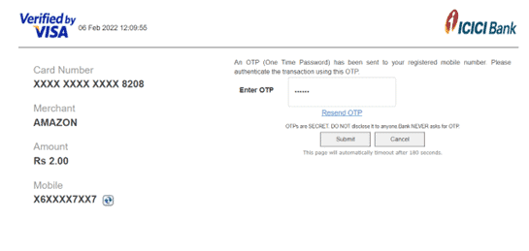
Step 7: Phone verification: Identity verification page that will already have your phone number, so you just have to select either “Text message or Voice call.” Provide a valid phone number, solve the captcha, and then click on Send SMS
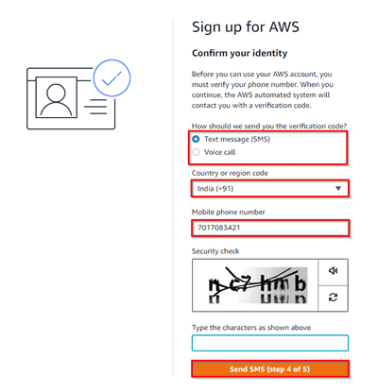
Step 8: After clicking on Send SMS or Call me Now, you will immediately receive a call or SMS from Amazon for a verification code. Enter your code, then click on Verify Code.
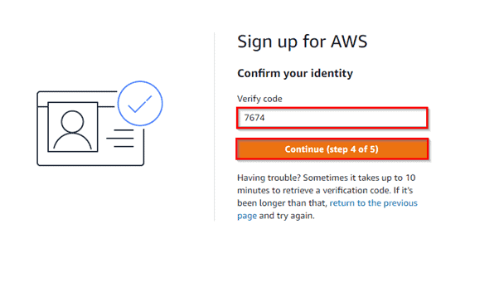
Step 9: Support plan: AWS support offers a selection of plans to meet your business needs. Select your suitable plan, then click continue.
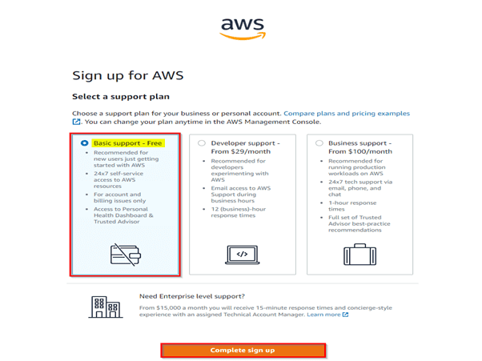
Note: All customers receive free basic support.
Step 10: Registration Confirmation page.
Once you have completed all the above steps and processes. You’ll get the confirmation page below. Now your account will be processed for activation. It may take somewhere between 30 minutes and 1 hour for you to receive an email confirmation that your Amazon Cloud Services account has been activated.
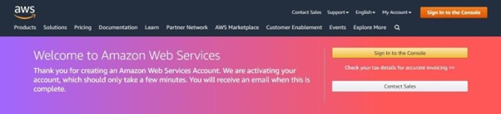
We have successfully created the AWS Free Tier Account.

Log in to the AWS Console
Note: Make Sure you log in as the root user in your AWS Account.
Step 1: Open your web browser, navigate to https://aws.amazon.com/console/, and click on Sign In to the console.

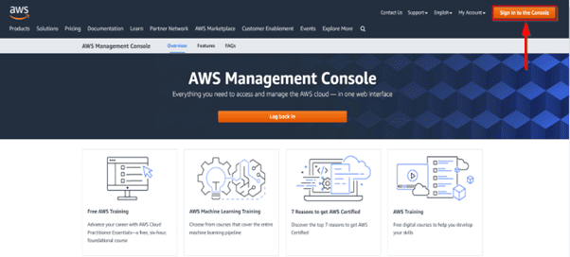

Step 2: Enter the username that you have chosen while creating the account and click on Next.

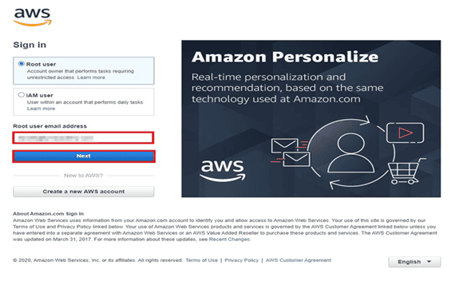
Step 3: Enter the password associated with the user and then click on Sign in.

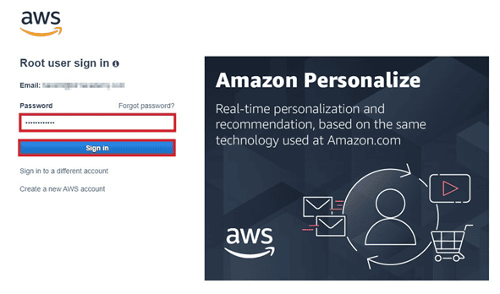

Step 4: You can see the home screen below after you log in.

